**Syntax Directed Translation Design**

**Grammar and Semantic Rule**

|  |  |
| --- | --- |
| **Non-Terminals** | **Terminals** |
| S | program (keyword) |
| BEGIN_BLOCK | begin (keyword) |
| BEGIN_STMT | end (keyword) |
| STMT | int (keyword) |
| DECLARATION | identifier |
| OPREATOR | number_literal |
| OP_STMT | operators (=, *) |
| FACTOR | separator (;, , ) |
| PRINT_CONTENT | string_literal |
| PRINT_STMT |  |

|  |  |
| --- | --- |
| **Production** | **Semantic rules** |
| S -> BEGIN_BLOCK  BEGIN_STMT | Initialize Symbol Table |
| BEGIN_BLOCK -> program id | BEGIN_BLOCK.program = id.lexval |
| BEGIN_STMT -> begin STMT* end | BEGIN_STMT.program = begin.lexval + STMT.program + end.lexval |
| STMT -> DECLARATION | STMT.inh = DECLARATION.inh |
| STMT -> PRINT_STMT | STMT.inh = PRINT_STMT.val |
| DECLARATION -> int OPERATOR ; | DECLARATION.inh = int.lexval  addType(DECLARATION.inh, OPERATOR.val) |
| DECLARATION -> OPERATOR , | addType(DECLARATION.inh, OPERATOR.val) |
| OPERATOR -> id = OP_STMT | OPERATOR.inh = OP_STMT.inh  addToSymbolTable(id.lexval, OPERATOR.inh) |
| OPERATOR -> id | OPERATOR.val = id.lexval  addToSymbolTable(id.lexval, null) |
| OP_STMT -> FACTOR | OP_STMT.val = FACTOR.val |
| OP_STMT -> OP_STMT * FACTOR | OP_STMT.val = OP_STMT.val * FACTOR.val  (compute calculations from inherited values) |
| FACTOR -> number_literal | FACTOR.val = number_literal.lexval(converted into type) |
| FACTOR -> id | FACTOR.val = id.lexval |
| PRINT_CONTENT -> string_literal | PRINT_CONTENT.val = string_literal.lexval |
| PRINT_CONTENT -> id | PRINT_CONTENT.val = id.val |
| PRINT_STMT -> print_line ( PRINT_CONTENT ) ; | Print output (PRINT_CONTENT.val) |

**Explanation of the Source Code**

Initialization of Symbol List “var”

At starting terminal S

At BEGIN_BLOCK

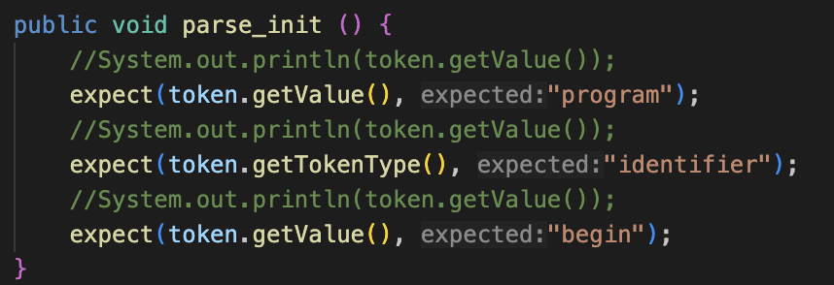

At DECLARATION, adding inherited values to symbol table

AT OP_STMT, getting and updating inherited values in symbol table

Logic for calculating value from inheritance

AT PRINT_STMT, printing output of relevant values in symbol table

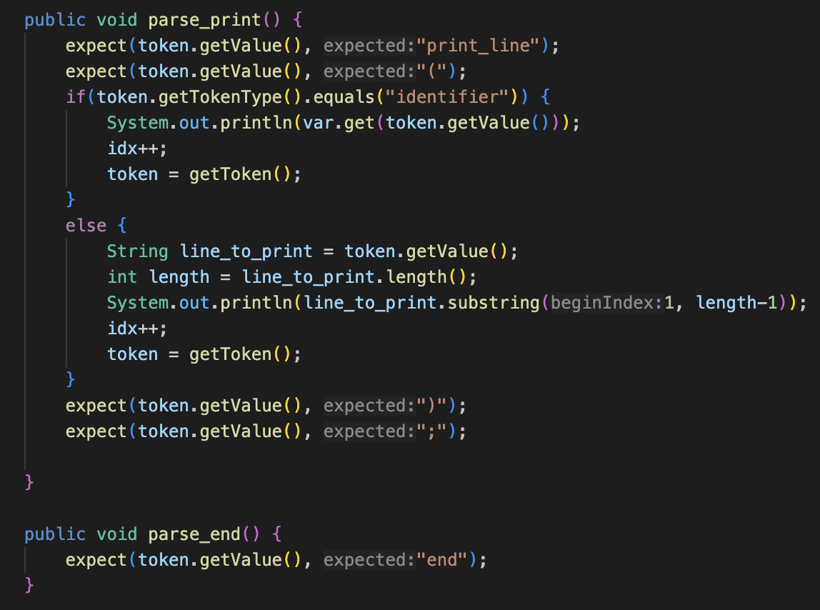

**Simple Flowchart**

